Crop Moisture Stress Index

National Oceanic and Atmospheric Administration

National Climatic Data Center

Crop Moisture Stress Index Imagery
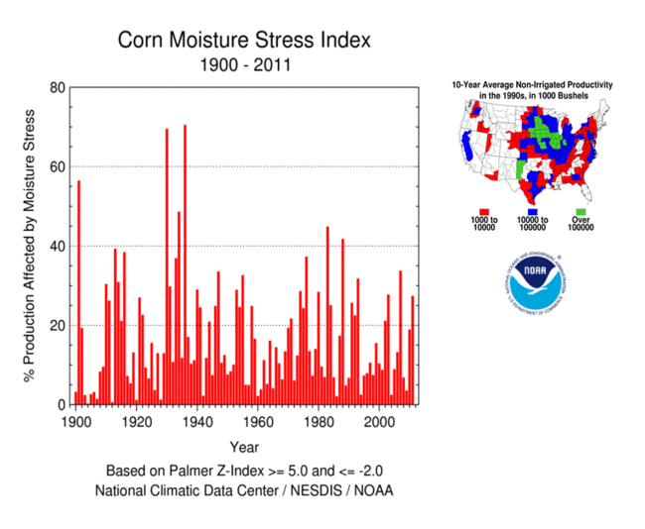
Data File: Corn Moisture Stress Index
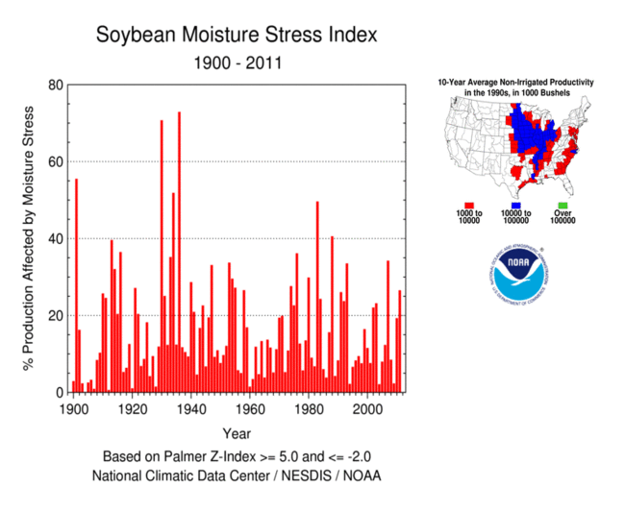
Data File: Soybean Moisture Stress Index

Index Overview
The Moisture Stress Index for corn and soybean crops is a measure of the effects of drought and catastrophic wetness on national crop yield and is calculated through the use of a drought index (the Palmer Z Index) and annual average crop productivity values within each U.S. climate division. Moisture stress, either a lack or an abundance of soil moisture during critical phases of the crop growth and development cycle, affects US average crop yield, particularly when moisture stress occurs in the most highly productive crop growing areas. Soil moisture conditions in July and August were found to be the best indicators of average crop yield for corn and soybeans, and as such, are used in creating the Moisture Stress Index.
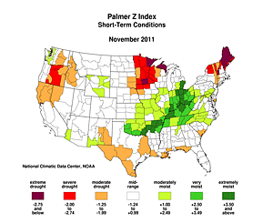
Figure 1. Short-term drought conditions within each U.S. climate division as indicated by the monthly Palmer Z Index (November 2011).
Calculations of the Moisture Stress Index are based on (1) the extent of severe to catastrophic drought or catastrophic wetness within the crop growing regions, i.e., those climate divisions with a Z Index value less than or equal to -2 or Z Index greater than or equal to +5, and (2) the average annual crop productivity* of each climate division within the crop growing region. Figure 1 is an example of short-term soil moisture conditions as measured by the monthly Palmer Z Index, while figures 2 and 3 show the 10-year average crop productivity values within the crop and soybean growing regions respectively.
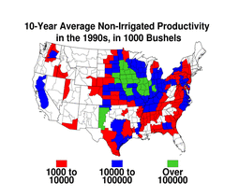
Figure 2. Non-irrigated productivity within Corn growing region by climate division (based on 1991-2000 average).
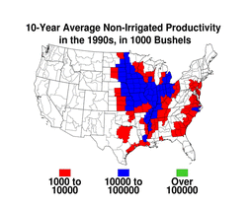
Figure 3. Non-irrigated productivity within Soybean growing region by climate division (based on 1991-2000 average).
Although the occurrence of drought during some months of the year would not be expected to impact crop productivity, the index was initially calculated for all months of the year. In cases when no climate division within the crop growing region has a Z index value less than or equal to -2 or a value greater than or equal to +5, the Moisture Stress Index equals zero. For months in which one or more climate division within the crop growing region has Z index values greater than or equal to +5, the Stress Index value for the month is calculated using a weighted average, with the average crop productivity values in the affected climate divisions as weights. For example, if severe to catastrophic drought or catastrophic wetness occurred during a particular month in X number of climate divisions that account for 20% of the crop growing region's productivity, the value of the Index would be 20 for that month. Not surprisingly the largest Moisture Stress Index values result when widespread drought or catastrophic wetness occurs in the most productive areas of the crop growing region.
Although these Moisture Stress Index values were calculated for each month of the year, soil moisture conditions in months outside the growing season should naturally have less impact on crop yield than those months that are part of the growing season. It is also known that some months of the growing season are more critical to the final success of the harvest than others. For corn and soybeans, the growing season generally runs from May through September, the reproductive season from July to August, and the harvest season from October to November (Brad Rippey, USDA, personal communication). To determine the months in which the Moisture Stress Index was a better indicator of the success of the year's crop, the monthly index values were correlated with the annual crop yield for the period 1970-2000**.
During development of the Moisture Stress Index, variations of the final index were evaluated. In addition to the Moisture Stress Index, which considers both drought and wetness, indices based solely on drought and another based solely on wetness were calculated. An index based solely on the effect that drought conditions have on crop yield was calculated (a Drought Stress Index) as well as an index based only on the effect that wetness (a Wetness Stress Index) has on crop yield was also calculated. In all cases, the effect of varying levels of drought and wetness severity was evaluated by using a variety of minimum drought and wetness thresholds (e.g., Z Index less than or equal to -2, -3 etc.. and Z Index greater than or equal to 2.5, 3.5, etc).
Evaluation of the monthly correlations of the index with annual crop yield for each variation showed that the Moisture Stress Index based on the Z Index values of less than or equal to -2 and greater than or equal to +5 (as described in the preceding paragraphs) best reflected the year to year changes in crop yield. Figures 4 and 5 show the resulting monthly and seasonal correlations for corn and soybean respectively. In each figure the first inset shows the annual crop yield, the second inset the correlations for severe to catastrophic drought stress only (drought stress), the third inset the correlations for catastrophic wetness stress only (wetness stress), and the final inset the correlations for the combined impacts of drought and wetness (moisture stress).
Average annual crop productivity was correlated with monthly crop index values and a plot of the correlations for each month created.
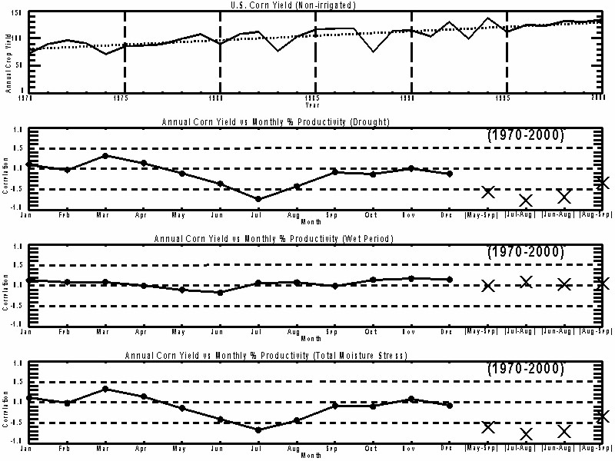
Figure 4. Monthly and seasonal correlations of each corn crop stress index (using severe to catastrophic drought, Z index less than or equal to -2 and catastrophic wetness, Z index greater than or equal to +5) with annual corn crop yield.
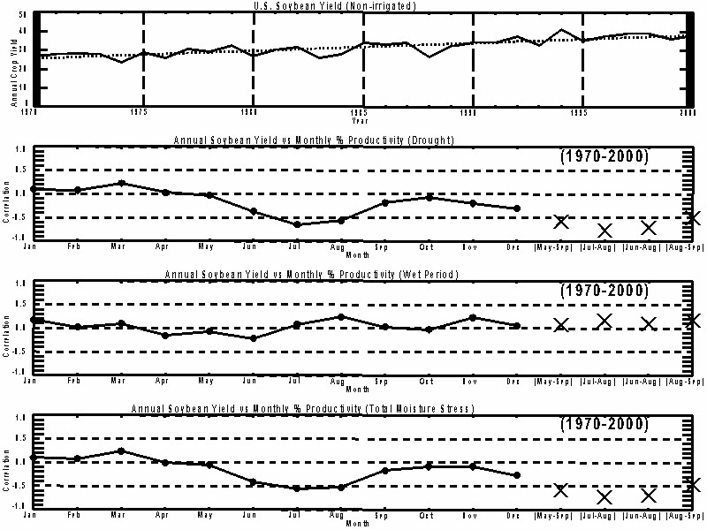
Figure 5. Monthly and seasonal correlations of each soybean crop stress index (using severe to catastrophic drought, Z index less than or equal to -2 and catastrophic wetness, Z index greater than or equal to +5) with annual soybean crop yield.
The strong correlations in July and August (for the Drought Stress Index and Moisture Stress Index), are consistent with the understanding that conditions during the reproductive season (July and August for corn and soybeans) are most critical in determining the outcome of a crop growing season (USDA, personal communication). To determine if some combination of months could explain more variance in crop yield, the crop stress indices were calculated over the July-August two-month period and other combinations of the highly correlated growing season months, e.g., June-August and May-September. Correlations for the July-August Drought and Moisture Stress Indices were found to be more highly correlated than any single month or other combination of months (see Figures 4 and 5). The strong correlations (as shown in Table 1) as well as the understanding that conditions during July and August are critical to the success of the crop growing season led us to base the Moisture Stress Indices on the July-August average. Although the correlations of the Drought Stress Index and the Moisture Stress Index were similar, the decision to use the CMSI instead of an index based solely on drought conditions was based on our knowledge that catastrophic wetness (such as that experienced during the summer of 1993) has an adverse impact on crop prodictivity. We wanted to ensure there was some method of accounting for this type of event in our index. The inclusion of instances where the Z index exceeds +5 allows us to do this. Figures 6 and 7 contain the Stress Index values for corn and soybean, respectively, for the period 1900-2001.

Table 1. Monthly and seasonal correlations as plotted in figures 6 and 7. Detrended annual crop yield versus detrended crop stress indices.
Corn: Annual corn yield vs monthly stress indices (1970-2000) as well as a multiple correlation coefficient using the drought and wetness incices versus corn yield.
 | Jan | Feb | Mar | Apr | May | Jun | Jul | Aug | Sep | Oct | Nov | Dec | May-  Sep | Jul-  Aug | Jun-  Aug | Aug-  Sep
DROUGHT | 0.10 | -0.03 | 0.31 | 0.14 | -0.12 | -0.37 | -0.74 | -0.43 | -0.08 | -0.13 | 0.00 | -0.13 | -0.57 | -0.77 | -0.69 | -0.35
WETNESS | 0.13 | 0.08 | 0.08 | -0.00 | -0.10 | -0.17 | 0.06 | 0.07 | -0.01 | 0.14 | 0.17 | 0.15 | -0.00 | 0.08 | 0.03 | 0.05
MOISTURE | 0.11 | -0.02 | 0.33 | 0.14 | -0.15 | -0.41 | -0.67 | -0.44 | -0.09 | -0.10 | 0.08 | -0.08 | -0.60 | -0.78 | -0.71 | -0.35

Soybean: Annual soybean yield vs monthly stress indices (1970-2000) as well as a multiple correlation coefficient using the drought and wetness incices versus corn yield.
 | Jan | Feb | Mar | Apr | May | Jun | Jul | Aug | Sep | Oct | Nov | Dec | May-  Sep | Jul-  Aug | Jun-  Aug | Aug-  Sep
DROUGHT | 0.10 | 0.07 | 0.22 | 0.03 | -0.03 | -0.37 | -0.64 | -0.56 | -0.18 | -0.08 | -0.19 | -0.30 | -0.58 | -0.77 | -0.70 | -0.49
WETNESS | 0.18 | 0.02 | 0.09 | -0.16 | -0.07 | -0.22 | 0.09 | 0.24 | 0.03 | -0.03 | 0.23 | 0.06 | 0.08 | 0.16 | 0.10 | 0.18
MOISTURE | 0.10 | 0.08 | 0.24 | -0.01 | -0.05 | -0.41 | -0.55 | -0.53 | -0.17 | -0.09 | -0.09 | -0.26 | -0.58 | -0.73 | -0.69 | -0.46
Figure 6. Moisture Stress Index for Corn since 1900.
Figure 7. Moisture Stress Index for Soybean since 1900.
*Crop productivity values within each climate division were used in calculating the Crop Stress Indices instead of divisional yield values because the highly productive areas of the US have a greater impact on the average national yield than those areas that traditionally produce fewer bushels or pounds of a particular crop. Conversely, the index, although calculated using average productivity values within individual climate divisions, is more closely related to national crop yield (for non-irrigated acreage) due to the impact that year-to-year changes in acreage planting practices can have on nationally averaged productivity.
USDA crop productivity numbers within each climate division for the period 1991 - 2000 were collected and averaged into mean crop productivity values. Irrigated acreage was excluded from all calculations. Midwest crops are primarily rain fed while irrigation practices increase in the Plains states, particularly in the crop growing regions farthest west.
**The crop yield time series were linearly detrended before correlations were calculated to remove the effect of improvements in crop science, technology, etc. that have occurred over the years. Because trends due to improving crop technology could not be separated from trends due to other factors such as climate change, the crop stress indices were also detrended. Correlations were calculated for the period 1970-2000, instead of the full 101-year period, as this was a period of high productivity and large year-to-year fluctuations in crop yield.

Questions?
For all climate questions, please contact the National Climatic Data Center's Climate Services and Monitoring Division:
Climate Services and Monitoring Division
NOAA/National Climatic Data center
151 Patton Avenue
Asheville, NC 28801-5001
fax: +1-828-271-4876
phone: +1-828-271-4800
email: ncdc.info@noaa.gov
To request climate data, please E-mail:ncdc.orders@noaa.gov

